Country of Origin Food Labelling Information Standard 2016
made under section 134 of Schedule 2 of the
Competition and Consumer Act 2010
Compilation No. 2
Compilation date: 12 August 2017
Includes amendments up to: F2017L01009

About this compilation
This compilation
This is a compilation of the Country of Origin Food Labelling Information Standard 2016 that shows the text of the law as amended and in force on 12 August 2017 (the compilation date).
The notes at the end of this compilation (the endnotes) include information about amending laws and the amendment history of provisions of the compiled law.
Uncommenced amendments
The effect of uncommenced amendments is not shown in the text of the compiled law. Any uncommenced amendments affecting the law are accessible on the Legislation Register (www.legislation.gov.au). The details of amendments made up to, but not commenced at, the compilation date are underlined in the endnotes. For more information on any uncommenced amendments, see the series page on the Legislation Register for the compiled law.
Application, saving and transitional provisions for provisions and amendments
If the operation of a provision or amendment of the compiled law is affected by an application, saving or transitional provision that is not included in this compilation, details are included in the endnotes.
Editorial changes
For more information about any editorial changes made in this compilation, see the endnotes.
Modifications
If the compiled law is modified by another law, the compiled law operates as modified but the modification does not amend the text of the law. Accordingly, this compilation does not show the text of the compiled law as modified. For more information on any modifications, see the series page on the Legislation Register for the compiled law.
Self-repealing provisions
If a provision of the compiled law has been repealed in accordance with a provision of the law, details are included in the endnotes.

Contents
Part 1—Preliminary 1
1 Name 1
2 Commencement 1
3 Authority 1
4 Purpose 1
5 Limit of application 1
6 Outline of this information standard 1
7 Interpretation 5
8 Meaning of grown, produced and made 5
9 Meaning of non-priority food 6
10 References to the logo and appropriate bar chart 6
11 Meaning of proportion and average proportion of ingredients by weight 7
12 Accounting for water when determining country of origin and proportion of Australian ingredients 8
13 Varying Australian content—methods for providing consumers with content information 8
Part 2—Country of origin labelling requirements 10
Division 1—Application of this Part 10
14 Application of this Part—retail sales and other sales for which labelling is required 10
Division 2—Labelling requirements 10
15 Packaged food, other than fresh fruit and vegetables in transparent packaging 10
16 Fresh fruit and vegetables in transparent packaging 11
17 Unpackaged meat, fish, fruit and vegetables 11
Division 3—Labelling requirements for food grown, produced, made or packaged in Australia 13
18 Food grown, produced or made in Australia exclusively from Australian ingredients 13
19 Other food made in Australia 14
20 Food grown, produced or made in Australia that is exported and re-imported 15
21 Varying Australian content—food made in Australia 16
22 Food packaged in Australia that includes food not grown, produced or made in Australia 17
23 Varying Australian content—food packaged in Australia 22
24 Non-priority food grown, produced or made in Australia 23
25 Non-priority food packaged in Australia 24
Division 4— Imported foods with Australian ingredients 24
26 Imported foods that have Australian ingredients 24
Part 3—Other sales where country of origin information must be provided 27
27 Sales for which labelling is not required but in relation to which information must be made available 27
Part 4—Legibility requirements, prohibitions and providing additional information 28
28 General legibility requirements 28
29 Restrictions on other uses of logo and bar chart in relation to food sold in Australia 28
30 Provision of additional material not prevented 28
31 Record-keeping 29
32 Provision of information to the regulator 29
Part 5—Transitional provisions 30
33 Food that complies with the Food Standards Code country of origin labelling requirements 30
Dictionary 31
1 Definitions—general 31
2 Meaning of Medical Institution 33
3 Definitions—particular foods 34
Endnotes 39
Endnote 1—About the endnotes 39
Endnote 2—Abbreviation key 40
Endnote 3—Legislation history 41
Endnote 4—Amendment history 42

Part 1—Preliminary

1 Name
This information standard is the Country of Origin Food Labelling Information Standard 2016.

2 Commencement
This information standard commences on 1 July 2016.

3 Authority
This information standard is made under section 134 of the Australian Consumer Law.

4 Purpose
The purpose of this information standard is to provide for country of origin labelling requirements for food for human consumption that is sold in Australia.
Note: In this information standard, ‘sell’ includes offer or display for sale.

5 Limit of application
This information standard does not operate to limit the exercise of a right given by or under the Trade Marks Act 1995 in relation to a registered trademark.

6 Outline of this information standard
Overview
This information standard provides for mandatory country of origin labelling requirements for food that is sold (including offered or displayed for sale) in Australia. It does not impose labelling requirements on food sold outside Australia.
Under this information standard, most food for retail sale in Australia must be labelled with a country of origin. There are different labelling requirements depending on whether the food was:
- grown, produced or made in Australia
- packaged in Australia
- grown, produced or made in another country
- packaged in another country.
Most food grown, produced, made or packaged in Australia will need to carry a standard mark. There will generally be two or more marks from which to choose. In addition to a country of origin statement, the marks include an indication of the proportion of Australian ingredients by ingoing weight through text and a bar chart. If all of the food in a display or package was grown, produced or made in Australia, the mark will also include a kangaroo logo. In some circumstances, more detailed information can be voluntarily added to the text in a standard mark.
For most imported food (food grown, produced, made or packaged in a country other than Australia), the country of origin statement will need to be in a clearly defined box. Where imported food includes Australian ingredients, a standard mark showing the proportion of Australian ingredients by ingoing weight through text and a bar chart may be used voluntarily.
For non-priority foods, the requirements for standard marks and the placement of origin statements in a box are voluntary, rather than mandatory. Non-priority foods are set out in section 9, and are foods for which Australian consumers are least concerned about origin information.
General provisions
The terms ‘grown’, ‘produced’ and ‘made’ are defined in section 8.
A food can be described as grown or produced in a country only if virtually all of its content is from, and virtually all of the processing is undertaken in, that country. Any food that can be described as grown or produced in a country can also be described as made in that country. A food can be described as made in a country if it was last substantially transformed into the final food through one or more processes that occurred in that country.
All standard marks in the information standard include a bar chart showing the proportion of Australian ingredients by ingoing weight. Section 10 includes a table listing bar charts and the ranges of percentages of Australian ingredients to which they apply. Section 11 sets out the methods for calculating the percentages of Australian ingredients by ingoing weight. Section 12 sets out how water is to be treated when calculating the percentages. Section 13 sets out the methods by which businesses can communicate more accurate information when the average percentage of Australian ingredients by ingoing weight is used in a standard mark in accordance with sections 21 and 23.
The labelling requirements are set out in Part 2. With some exceptions, Part 2 applies to retail sales of food. The labelling requirements vary depending on whether the food falls within one of the following three categories of food:
- packaged food, other than fresh fruit and vegetables in transparent packaging
- fresh fruit and vegetables in transparent packaging
- unpackaged meat, fish, fruit and vegetables.
These categories align with the categories of food required to be labelled with a country of origin under the Australia New Zealand Food Standards Code (Food Standards Code) at the time the information standard commenced. This means there has been no change to the range of foods that must be labelled with a country of origin. Particular foods or classes of foods are defined in Part 3 of the Dictionary at the end of this information standard.
Food grown, produced or made in Australia
If the food was grown, produced or made in Australia exclusively from Australian ingredients, the information must be in the form of one of the standard marks set out in section 18. These marks include the following features:
- a logo to assist the consumer to easily identify that the food was grown, produced or made in Australia:
- a full bar chart to indicate that the food’s ingredients are exclusively Australian:
- a statement indicating that the food was grown, produced or made in Australia and that its ingredients are exclusively Australian.
If the food was grown, produced or made in Australia and some of its ingredients are not Australian, the information must be in the form of one of the standard marks set out in section 19 (subject to section 21). The marks include the following features:
- a logo to assist the consumer to easily identify the food was grown, produced or made in Australia:
- one of the following bar charts to provide a visual indication of the proportion, by ingoing weight, of the food’s Australian ingredients:
- a Made in Australia statement, together with a statement that aligns with the bar chart and clearly states the minimum proportion, by ingoing weight, of the food’s Australian ingredients.
Where a particular ingredient is sourced exclusively from a particular country, text naming the origin of that ingredient can be added to the standard mark.
If food grown, produced or made in Australia is exported and re-imported without substantial transformation, but with some processing overseas (for example, cleaning, shelling, packaging or re-packaging), then the processing that occurred overseas will have to be declared in the standard mark from section 18 or 19, as appropriate.
If the food was grown, produced or made in Australia and the proportion by ingoing weight of Australian ingredients varies over time, the information may be in the form of a mark that includes a statement of the average content of Australian ingredients and a means for consumers to access further details off-pack, in accordance with section 21. The mark includes the following features:
- a logo to assist the consumer to easily identify the food was grown, produced or made in Australia:
- one of the following bar charts to provide a visual indication of the average proportion, by ingoing weight, of the food’s Australian ingredients:
- a Made in Australia statement, together with a statement aligned with the bar chart that indicates the average proportion by ingoing weight of the food’s Australian ingredients and how to get further details about the Australian content of the food.
Food packaged in Australia
If the food was packaged in Australia (but not all of the food in the package was exclusively grown, produced or made in Australia), the labelling must include one of the standard marks set out in section 22 (subject to section 23). These marks do not include the kangaroo logo, but do include a bar chart, a Packed in Australia statement and an Australian ingredient statement, aligned with the bar chart, similar to that for food that was made in Australia. Where a particular ingredient is sourced exclusively from a particular country, text naming the origin of that ingredient can be added to the standard mark.
If all the food is from a single country, the label must at least state that the food in the package was grown, produced or made in that country, and may include a standard mark that also includes a statement that it was packed in Australia, together with an unfilled bar chart.
If the food was packaged in Australia and the proportion by ingoing weight of the food’s ingredients varies over time, the information may be in the form of a standard mark set out in section 23. These marks do not include the kangaroo logo, but do include a bar chart and a statement indicating the average proportion, by ingoing weight, of the food’s Australian ingredients and how to get further details about the Australian content of the food.
Non-priority food grown, produced, made or packaged in Australia
For non-priority foods (foods set out in section 9), the use of the standard marks in accordance with sections 18 to 23 is voluntary rather than mandatory. Where the kangaroo logo and/or a bar chart is used on non-priority food, they must be used as part of a standard mark in accordance with those sections.
Imported food
If the food was not grown, produced, made or packaged in Australia, the labelling will be required to meet the requirements in sections 15, 16 or 17. Briefly, it must identify:
- the country of origin of the food, if it is from a single country (it may also identify where the food was packaged if this was a different country), or
- if the food is from more than one country:
  - the country where the food was packaged, if applicable; and
  - that the food is of multiple origins.
Unless the packaged food is non-priority (see section 9), the country of origin information must be in a clearly defined box.
As an alternative to a simple statement about the origin of the food, if the food was produced, made or packaged in a country other than Australia but with Australian ingredients, the labelling may include one of the standard marks set out in section 26. These marks do not include the kangaroo logo, but do include a bar chart and a statement indicating the proportion, by ingoing weight, of the food’s Australian content. Where a particular ingredient is sourced exclusively from a particular country, text naming the origin of that ingredient can be added to this standard mark.
Other requirements
Part 3 applies to sales other than retail sales. It enables a food processor or retailer who purchases wholesale foods or ingredients to obtain from the seller the country of origin information that will be needed to comply with this information standard.
Part 4 sets out:
- general legibility requirements in relation to labelling
- certain prohibitions on the use of the logo and bar chart
- the provision of additional information about the country of origin of a food
- record keeping requirements for certain food
- requirements to provide information to regulators when requested.
Part 5 sets out transitional provisions to deal with foods that have already been labelled or are labelled within two years of the commencement of this information standard.
A Dictionary is included that defines certain words and expressions used in this information standard. The Dictionary is divided into general definitions, definitions relating to medical institutions and food related definitions.

7 Interpretation
Terms in the Dictionary at the end of this information standard have the meaning given by the Dictionary.

8 Meaning of grown, produced and made
- In this information standard:
grown:
- a food or ingredient was grown in a country if it:
- was materially increased in size or materially altered in substance in that country by natural development; or;
- germinated or otherwise arose in, or issued in, that country; or
- was harvested, extracted or otherwise derived rom an organism that has been materially increased in size, or materially altered in substance, in that country by natural development;
- a food consisting of more than one ingredient is also grown in a country if:
- each of its significant ingredients was grown in that country; and
- all, or virtually all, of the processing occurred in that country.
made: a food was made in a country if it underwent its last substantial transformation in that country.
produced: a food was produced in a country if:
- each of its significant ingredients was grown or otherwise wholly obtained in that country; and
- all, or virtually all, of the processing occurred in that country.
- If a food fits in more than one of the categories defined in subsection (1), and this information standard has different requirements for the different categories, the labelling complies with this information standard if it satisfies the requirements for one of the categories.
Example: Where a food could be described either as having been made in Australia from Australian ingredients, or as having been produced in Australia, the label could have, with the logo and the 100% bar chart, any of the following: ‘Made in Australia from Australian ingredients’; ‘Produced in Australia’; ‘Grown in Australia’; ‘Australian [kind of food]’; or ‘Made in Australia from 100% Australian ingredients’.

9 Meaning of non-priority food
In this information standard:
non-priority food means the following:
- seasonings;
- confectionary;
- biscuits and snack food;
- bottled water;
- soft drinks and sports drinks
- tea and coffee;
- alcoholic beverages.

10 References to the logo and appropriate bar chart
- In this information standard a reference to the logo is a reference to the following logo:
- In this information standard, a reference to the appropriate bar chart for a mark is a reference to the bar chart in the following table that represents ‘P%’ in the mark:
Range for ‘P%’ | Bar chart that represents range
Less than 10%
10% to 19%
20% to 29%
30% to 39%
40% to 49%
50% to 59%
60% to 69%
70% to 79%
80% to 89%
90% to 94%
95% to 99%
100%

11 Meaning of proportion and average proportion of ingredients by weight
- In this information standard, a reference to the proportion by weight of the Australian ingredients of a food is a reference to the total ingoing weight of the ingredients from Australia as a proportion of the total ingoing weight of all the ingredients of the food, expressed as a percentage.
- In this information standard, a reference to the average proportion by weight of the Australian ingredients of a packaged food is a reference to the average determined over a continuous 1, 2 or 3 year period that ends no later than 2 years before the date the labelling is affixed to the package.
- To avoid doubt, a substance or food used as a processing aid is not an ingredient for the purposes of subsection (1) or (2).
- For this section:
- an ingredient that was exclusively grown or produced in Australia is from Australia; and
- if a compound ingredient of a food is itself made from ingredients from more than one country (sub-ingredients), the ingoing weight of that ingredient is attributed to the different countries, one of which is Australia, in accordance with the proportion by weight of the sub ingredients in that compound ingredient.
Example: A pasta sauce is made in Australia from 70% Australian ingredients by weight. It is then used to make a lasagne. The ingoing weight of the pasta sauce is attributed 70% to Australia and 30% to other countries in calculating the proportion by weight of the Australian ingredients of the lasagne.

- In this section:
used as a processing aid has the meaning given by section 1.1.2—13 of the Food Standards Code.

12 Accounting for water when determining country of origin and proportion of Australian ingredients
- This section sets out how water is to be accounted for when determining the country of origin of a food or calculating the proportion by weight of specified ingredients of a food.
- Water that reconstitutes dehydrated or concentrated ingredients or other components of food (including food additives) is taken to have the country of origin of that ingredient or component.
- Water otherwise added as an ingredient to a food is taken to have the country of origin in which it was collected or harvested
- Where a liquid packing medium for a food is not generally consumed as part of the food, water that forms part of the liquid packing medium is not to be counted when determining the proportion by weight of specified ingredients.
Examples: This subsection would apply to water that forms part of a pickling brine in a jar of pickled onions, but not to water that is an ingredient of a syrup in a can of peaches.
- For this section a liquid packing medium includes, but is not limited to, the following:
- water;
- aqueous solutions of sugars or salt (for example, brines or syrups);
- fruit and vegetable juices in canned fruits and vegetables;
- vinegar.

13 Varying Australian content—methods for providing consumers with content information
- The following are the methods that may be used to provide a consumer with information about Australian content of food for purposes of section 21 or 23:
- the consumer may use a smartphone app or other software to scan a barcode or similar device;
- the consumer may contact a telephone number and get the information by providing an identifier for the food that is included on the label, such as a barcode, batch number, date of manufacture or date mark; or
- the consumer may use a website and get the information by providing an identifier for the food that is included on the label, such as a barcode, batch number, date of manufacture or date mark.
- The following are the identifying phrases that may be used in the mark to indicate a method mentioned in subsection (1):
- for use of an app or software—‘- Scan barcode for details’;
- for use of telephone—‘- Call [phone number] for details’ where ‘[phone number]’ is a phone number that may be contacted during business hours;
- for use of a website—‘- Visit [website] for details’, where ‘[website]’ is the website address.

Part 2—Country of origin labelling requirements

Division 1—Application of this Part

14 Application of this Part—retail sales and other sales for which labelling is required
- This Part applies in relation to a sale of food in Australia if:
- the sale is a retail sale; or
- the sale is not a retail sale, but the food is sold as suitable for retail sale without any further processing, packaging or labelling.
- However, this Part does not apply to a food that:
- is sold to the public for immediate consumption by any of the following:
- a restaurant;
- a canteen;
- a school;
- a caterer or a self-catering institution;
- a prison;
- a hospital or a medical institution; or
- was made and packaged on the premises where it is sold; or
- is delivered, packaged and ready for consumption, at the express order of the purchaser (other than when the food is sold from a vending machine);
- is sold at a fund-raising event; or
- food for special medical purposes.
Application to small packages
- If a provision of this Part requires labelling for a food to include a mark that includes a logo or a bar chart, the provision is satisfied in relation to a small package if a label attached to the package includes the words in the mark, in a clearly defined box, without any logo or bar chart.
- In this section:
food for special medical purposes has the meaning given by section 1.1.2—5 of the Food Standards Code.
small package has the meaning given by section 1.1.2—2 of the Food Standards Code.

Division 2—Labelling requirements

15 Packaged food, other than fresh fruit and vegetables in transparent packaging
- This section applies in relation to food for sale (whether or not a retail sale) if it is in a package that is required to bear a label under a standard in the Food Standards Code.
Note: See Australia New Zealand Food Standards Code – Standard 1.2.1 – Requirements to have labels or otherwise provide information. For labelling requirements where the food for sale has more than 1 layer of packaging, see sections 1.2.1—6 and 1.2.1—20.
- If provisions in Division 3 apply to the food, the package must bear a label that meets the requirements of those provisions.
Note: Division 3 applies to food that was grown, produced, made or packaged in Australia.
- Otherwise, the package must bear a label with:
- a statement of the country of origin of the food in the package; or
- if the food was packaged using food from more than one country—a statement that:
(i) identifies the country where the food was packaged; and
(ii) indicates that the food is of multiple origins or that it is comprised of imported ingredients.
Note: This subsection applies to food that was not grown, produced, made or packaged in Australia.
If some or all of its significant ingredients were made in Australia, section 26 permits the use of a mark with a bar chart to indicate this. Using the mark will satisfy this subsection and subsection (4).
- For food other than non-priority food, the statement mentioned in subsection (3) must be in a clearly defined box.

16 Fresh fruit and vegetables in transparent packaging
- This section applies in relation to food for retail sale that:
- consists solely of unprocessed fruit and vegetables, whether whole or cut; and
- is displayed for sale in a package that does not obscure the nature or quality of the fruit and vegetables.
- If provisions in Division 3 apply to the food, the food must bear a label on the package, or have labelling that accompanies it or is displayed in connection with its sale, that meet the requirements of those provisions.
Note: Division 3 applies to food that was grown, produced, made or packaged in Australia.
- Otherwise, the food must bear a label on the package, or have labelling that accompanies it or is displayed in connection with its sale, that:
- identifies the country of origin of the fruit and vegetables; or
- if the fruit or vegetables are from more than one country—indicates that the fruit or vegetables are of multiple origins or that it is comprised of imported ingredients.
Note: This subsection applies to food that was not grown, produced, made or packaged in Australia.
If some or all of its significant ingredients are Australian, section 26 permits the use of a bar chart and a statement to indicate this. Using the mark will satisfy this subsection.
- If the statement mentioned in subsection (3) is on the package, it must be in a clearly defined box.

17 Unpackaged meat, fish, fruit and vegetables
- This section applies to food for retail sale that:
- is any of the following:
- fish, including fish that has been mixed or coated with 1 or more other foods;
- pork;
- beef;
- veal;
- lamb;
- hogget;
- mutton;
- chicken;
- fruit and vegetables;
- a mix of any of the above foods; and
- is displayed for sale other than in a package.
Food grown, produced or made in Australia
- If provisions in Division 3 apply to the food, the food must bear a label, or have labelling that accompanies it or is displayed in connection with its sale that meets the requirements of those provisions.
Food not grown, produced or made in Australia
- If provisions in Division 3 do not apply to the food, the food must bear a label, or have labelling that accompanies it or is displayed in connection with its sale, that:
- identifies the country of origin of the food; or
- if the food is from more than one country—indicates that the food is of multiple origins or that it is comprised of imported ingredients.
Note: Subsection 28(4) describes requirements for labels displayed in connection with food.
Mixed bins of single ingredient foods
- Despite subsection (2) and Division 3, if a single ingredient food is displayed for sale in a mixed bin that contains both Australian and imported items, the food complies with this section if labelling that is displayed in connection with its sale indicates that fact.
Note: If the seller chooses to rely on labels on individual items, each label will need to comply with subsection (2) or (3), as appropriate.
Interpretation
- A reference to a food listed in paragraph (1)(a) includes a reference to a food that has been:
- cut, filleted, sliced, minced or diced; or
- pickled, cured, dried, smoked, frozen or preserved by other means; or
- marinated; or
- cooked.

Division 3—Labelling requirements for food grown, produced, made or packaged in Australia

18 Food grown, produced or made in Australia exclusively from Australian ingredients
- This section applies to food if:
- it was grown, produced or made in Australia; and
- its ingredients are exclusively of Australian origin.
Note: This section will not apply if any ingredient, or any ingredient of a compound ingredient, is not grown or produced in Australia.
For definition of compound ingredient, please refer to subsection 11(4).
- The labelling must include one of the following marks:
where:
- ‘X’ is the phrase ‘Grown in’, ‘Produced in’, ‘Produce of’ or ‘Product of’ as appropriate; and
- ‘Y’ is the word ‘Grown’, ‘Produce’, ‘Product’ or the kind of food, as appropriate.

19 Other food made in Australia
- This section applies to food if:
- it was grown, produced or made in Australia; and
- some of its ingredients are not exclusively of Australian origin.
- Subject to subsection (3), if some of the food’s ingredients are of Australian origin, or partly of Australian origin, the labelling must include one of the following marks:
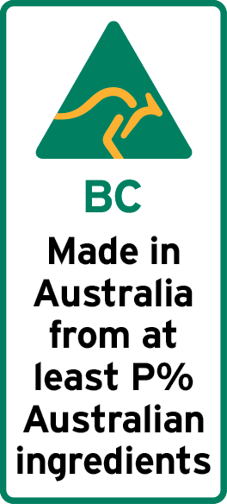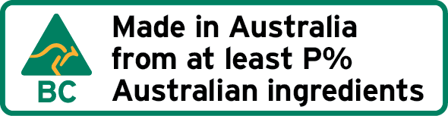
where:
- ‘BC’ is the appropriate bar chart to represent P% of Australian ingredients (see section 10); and
- ‘P%’, in which P is a whole number, is not more than the proportion by weight of the Australian ingredients of the food.
- If less than 10% of the food’s ingredients by weight are Australian, the labelling may include one of the following marks:
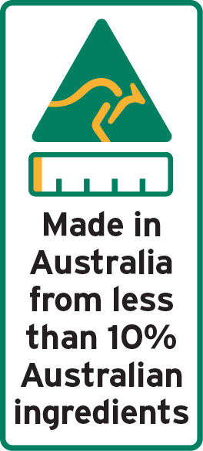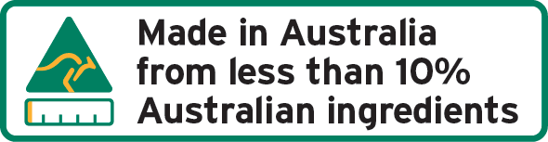

- If none of the food’s ingredients are Australian, the labelling must include one of the following marks:
Reference in mark to an ingredient from a particular country
- In a mark required or permitted under this section, a phrase may be added at the end that names one or more of the ingredients of the food and specifies the country of origin of each ingredient named, provided:
- the phrase starts with the word ‘with’; and
- each ingredient named originates exclusively in the country specified as the origin of that ingredient.
Examples: ‘Made in Australia from at least 60% Australian ingredients with prawns and peanuts from Thailand’
‘Made in Australia from at least 60% Australian ingredients with prawns from Thailand, pineapples from Vietnam and peanuts from Malaysia’
‘Made in Australia from at least 60% Australian ingredients with Australian beef’

20 Food grown, produced or made in Australia that is exported and re-imported
If food to which section 18 or 19 applies was:
- grown, produced or made in Australia; and
- exported from Australia and then re-imported to Australia:
the mark required to be included in the labelling must also include a description, in brackets, of the processing that occurred outside Australia.
Note: Section 18 or 19 will apply only if the food was grown, produced or made in Australia, so that it cannot have undergone a substantial transformation when abroad, nor can it have been combined with non-Australian ingredients outside Australia. However, it may have undergone some processing (for example, cleaning, shelling, packaging, re-packaging) and it may have been combined with other Australian ingredients.
For example, the label for Australian macadamias sent to Fiji for shelling, sorting and packing before being returned to Australia would include a statement ‘(shelled, sorted and packed in Fiji)’.

21 Varying Australian content—food made in Australia
- This section applies to packaged food that was made in Australia if the proportion by weight of the Australian ingredients of the food varies over time.
- Despite sections 18 and 19, the labelling of the food complies with this information standard if:
- the labelling includes:
- one of the appropriate marks under this section; and
- any information, such as a barcode or other device, batch number, lot, date of manufacture or date mark, that is needed to enable a consumer to obtain information by a method in accordance with section 13; and
- a consumer who follows the method indicated by the mark is able to find out:
- the proportion by weight of Australian ingredients of the food in the package; and
- if the period that was used to calculate the average specified in the mark does not appear on the labelling—that period.
- If the average proportion by weight of the Australian ingredients of the food is not less than 1%, the following are appropriate marks:
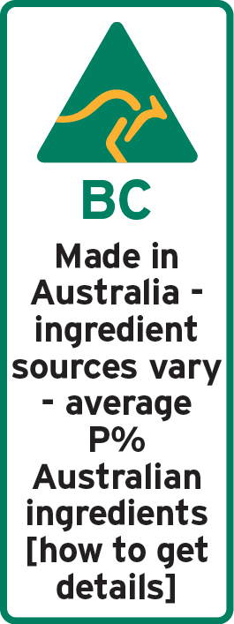
where:
- ‘BC’ is the appropriate bar chart to represent P% of Australian ingredients (see section 10); and
- ‘P%’, in which P is a whole number, is not more than the average proportion by weight of the Australian ingredients of the food; and
- ‘[how to get details]’ is the identifying phrase for an information method that satisfies section 13.
- If the average proportion by weight of the Australian ingredients of the food is less than 10%, the following are also appropriate marks:
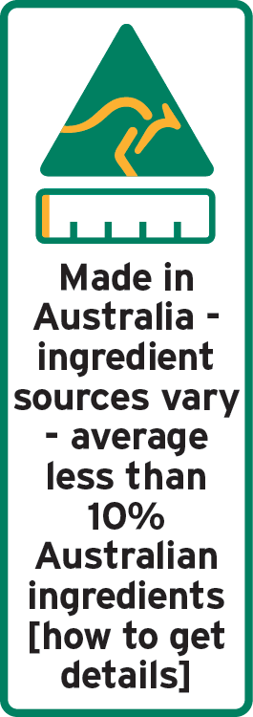
where ‘[how to get details]’ is the identifying phrase for an information method that satisfies section 13.

22 Food packaged in Australia that includes food not grown, produced or made in Australia
- This section applies to food that:
- was packaged in Australia; and
- is not food to which section 18 or 19 applies.
- If:
- the food in the package was made in a single country other than Australia; and
- the ingredients of the food are exclusively of Australian origin,
the labelling must include:
- a statement that the food was made in that country, in a clearly defined box; or
- one of the following marks:
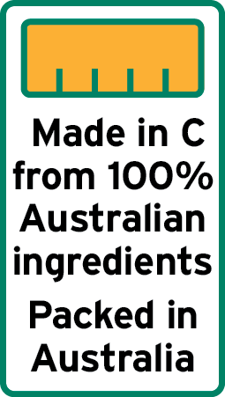
where:
- ‘C’ is the name of the relevant country; and
- ‘Packed’ may be replaced by ‘Packaged’.
Example: Australian fruit is exported to Singapore and converted into juice before being shipped back to Australia in bulk for packaging here. The label could state in a clearly defined box that it was ‘Made in Singapore’. Alternatively, a standard label could be used that includes a fully shaded bar chart and a statement like ‘Made in Singapore from 100% Australian ingredients Packaged in Australia’, all in a clearly defined box. The label would not include the kangaroo logo – even though all of the ingredients are Australia, the juice was made in Singapore.
- Subject to subsection (4), if:
- the food in the package was made in a single country other than Australia; and
- some of the ingredients of the food are of Australian origin,
the labelling must include:
- a statement that the food was made in that country, in a clearly defined box; or
- one of the following marks:
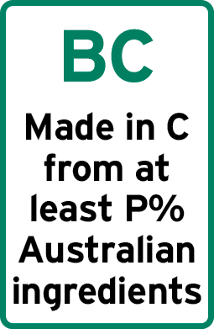
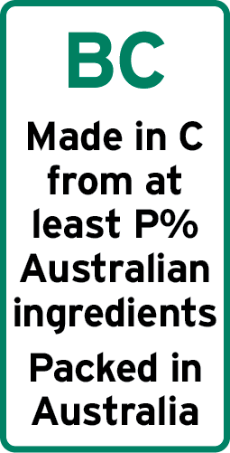
where:
- ‘BC’ is the appropriate bar chart to represent P% of Australian ingredients (see section 10); and
- ‘C’ is the name of the relevant country; and
- ‘P%’, in which P is a whole number, is not more than the proportion by weight of the Australian ingredients of the food; and
- ‘Packed’ may be replaced by ‘Packaged’.
- If:
- the food in the package was made in a single country other than Australia; and
- some but less than 10% of the ingredients of the food by weight is of Australian origin,
the labelling may include one of the following marks:
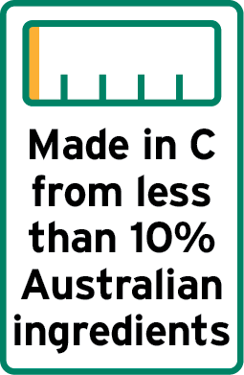
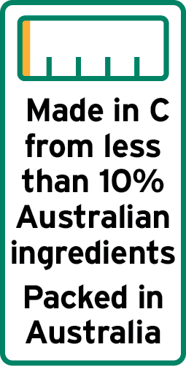
where:
- ‘C’ is the name of the relevant country; and
- ‘Packed’ may be replaced by ‘Packaged’.

- If:
- the food in the package was grown, produced or made in a single country other than Australia; and
- none of the ingredients of the food is of Australian origin,
the labelling must include:
- a statement that the food was grown, produced or made in that country, as appropriate, in a clearly defined box; or
- one of the following marks:
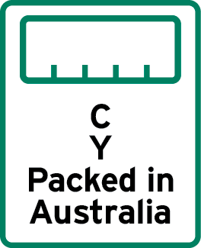
where:
- ‘X’ is:
- the phrase ‘Made in’; or
- if all significant ingredients are from a single overseas country, the phrase ‘Grown in’, ‘Produced in’, ‘Produce of’, ‘Product of’, as appropriate (see section 8);
- ‘Y’ is:
- the word ‘Made’;
- the word ‘Grown’, ‘Produced’ or ‘Product’, as appropriate (see section 8); or
- the kind of food;
- ‘C’ is the name of the relevant country, or the adjectival form of that name, as appropriate; and
- ‘Packed’ may be replaced by ‘Packaged’.
- Subject to subsection (7), if:
- the food in the package was not grown, produced or made in a single country; and
- some of the ingredients of the food are of Australian origin,
the labelling must include one of the following marks:
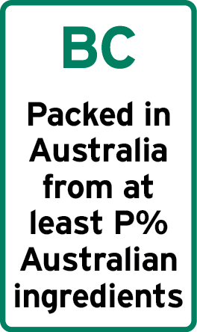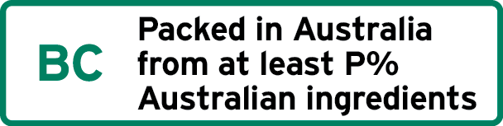
where:
- ‘BC’ is the appropriate bar chart to represent P% of Australian ingredients (see section 10); and
- ‘Packed’ may be replaced by ‘Packaged’; and
- ‘P%’, in which P is a whole number, is not more than the proportion by weight of the Australian ingredients of the food.
Note: This Subsection applies to packaged food of multiple origins that contains Australian food or ingredients.
For example, Australian fruit or vegetables mixed with imported fruit or vegetables; Australian nuts mixed with imported nuts.
- If:
- the food in the package was not grown, produced or made in a single country; and
- some but less than 10% of the ingredients of the food by weight is of Australian origin,
the labelling may include one of the following marks:
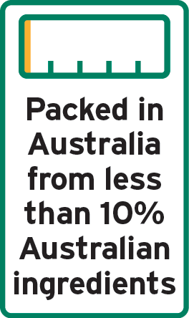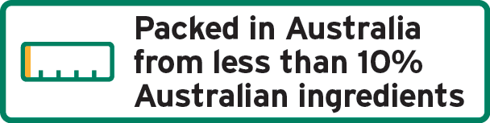
where ‘Packed’ may be replaced by ‘Packaged’.
- If:
- the food in the package was not grown, produced or made in a single country; and
- none of the ingredients of the food is of Australian origin,
the labelling must include one of the following marks:
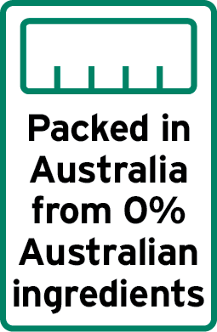
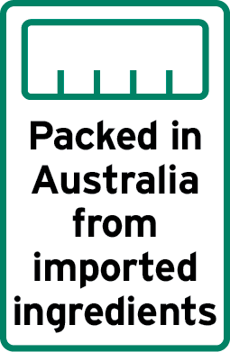
where ‘Packed’ may be replaced by ‘Packaged’.
Note: This subsection applies to packaged food of multiple origins that contains no Australian food or ingredients.
For example, mixed fruit, vegetables or nuts imported from two or more countries not including Australia.
Reference in mark to an ingredient from a particular country
- In a mark required or permitted under this section other than subsection 22(2), a phrase may be added at the end that names one or more of the ingredients of the food and specifies the country of origin of each ingredient named, provided:
- the phrase starts with the word ‘with’; and
- each ingredient named originates exclusively in the country specified as the origin of that ingredient.
Examples: ‘Packed in Australia from at least 80% Australian ingredients with walnuts from the United States of America’
‘Packed in Australia from imported ingredients with lychees from Thailand, pineapples from Malaysia and mangoes from the Philippines’
‘Packed in Australia from 0% Australian ingredients with Canadian blueberries’

23 Varying Australian content—food packaged in Australia
- This section applies to food to which section 22 applies (other than food grown, produced or made in a single overseas country) if the proportion by weight of the ingredients of the food varies over time.
- Despite section 22, the labelling of the food complies with this information standard if:
- the labelling includes:
- one of the appropriate marks under this section; and
- any information, such as a barcode or other device, batch number, lot, date of manufacture or date mark, that is needed to enable a consumer to obtain information by a method in accordance with section 13; and
- a consumer who follows the method indicated by the mark is able to find out:
- the proportion by weight of Australian ingredients of the food in the package; and
- if the period that was used to calculate the average specified in the mark does not appear on the labelling—that period.
- If the average proportion by weight of the Australian ingredients of the food is at least 1%, the following are appropriate marks:
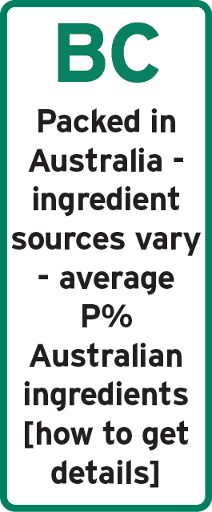
where:
- ‘BC’ is the appropriate bar chart to represent P% of Australian ingredients (see section 10); and
- ‘Packed’ may be replaced by ‘Packaged’; and
- ‘P%’, in which P is a whole number, is not more than the average proportion by weight of the Australian ingredients of the food; and
- ‘[how to get details]’ is the identifying phrase for an information method that satisfies section 13.
- If the average proportion of the Australian ingredients of the food is less than 10%, the following are also appropriate marks:
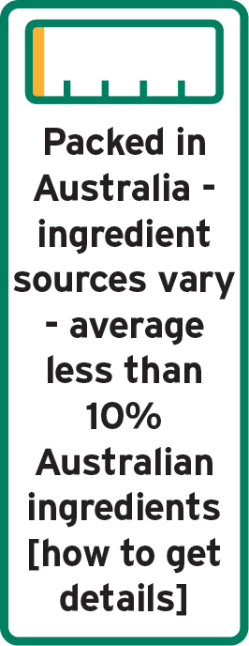
where:
- ‘[how to get details]’ is the identifying phrase for an information method that satisfies section 13; and
- ‘Packed’ may be replaced by ‘Packaged’.

24 Non-priority food grown, produced or made in Australia
- This section applies to non-priority food that was grown, produced or made in Australia.
- A requirement under section 18 or 19 for the labelling to include a specified mark is taken to be satisfied if the labelling instead includes a statement indicating:
- if the food was grown in Australia—that the food was grown in Australia; or
- if the food was produced in Australia—that the food was produced in Australia; or
- if the food was made in Australia—that the food was made in Australia.

25 Non-priority food packaged in Australia
- This section applies to non-priority food that:
- was packaged in Australia; and
- was not packaged using food that was exclusively grown, produced or made in Australia.
- A requirement under section 22 for the labelling to bear a specified mark is taken to be satisfied if the labelling instead includes:
- if the food in the package is from a single country—a statement of the country of origin of the food (whether or not it also includes a statement that the food was packaged in Australia); or
- if the food in the package is from more than one country:
- a statement that the food was packaged in Australia; and
- a statement that indicates that the food is of multiple origins or that it is comprised of imported ingredients.

Division 4— Imported foods with Australian ingredients

26 Imported foods that have Australian ingredients
- This section applies to food if:
- Division 3 does not apply (this is therefore food that was grown, produced, made or packaged in a country other than Australia); and
- some or all of the food’s ingredients were grown, produced or made in Australia.
- If the food is made in a country other than Australia, but the food’s ingredients are exclusively of Australian origin, the labelling may include one of the following marks:
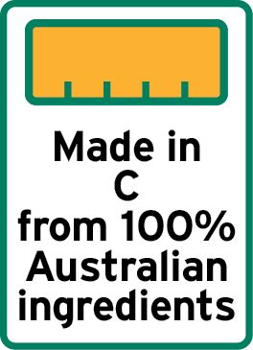
where ‘C’ is the name of the relevant country.

- If some, but not all of the food’s ingredients by weight are Australian, the labelling may include one of the following marks:
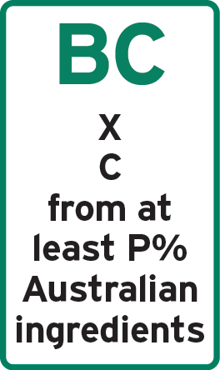
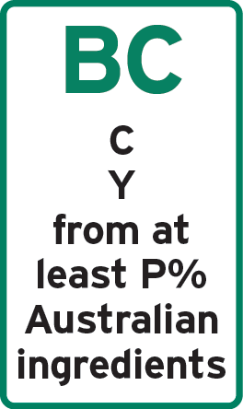
where:
- ‘BC’ is the appropriate bar chart to represent P% of Australian ingredients (see section 10); and
- ‘X’ is the phrase ‘Made in’, ‘Packed in’ or ‘Packaged in’, as appropriate; and
- ‘Y’ is the word ‘Made’ or the kind of food, as appropriate; and
- ‘C’ is the name of the relevant country, or the adjectival form of that name, as appropriate; and
- ‘P%’, in which P is a whole number, is not more than the proportion by weight of the Australian ingredients of the food.
- If less than 10% of the food’s ingredients by weight are Australian, the labelling may include one of the following marks:
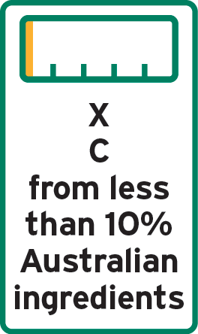
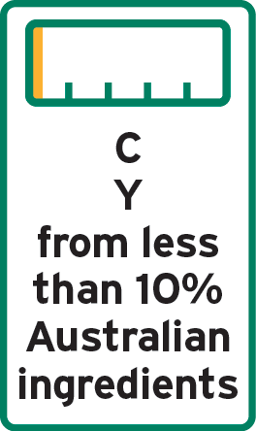
where:
- ‘X’ is the phrase ‘Grown in’, ‘Produced in’, ‘Produce of’, ‘Product of’, ‘Made in’, ‘Packed in’ or ‘Packaged in’, as appropriate; and
- ‘Y’ is the word ‘Grown’, ‘Produce’, ‘Product’, ‘Made’ or the kind of food, as appropriate; and
- ‘C’ is the name of the relevant country, or the adjectival form of that name, as appropriate.
Reference in mark to an ingredient from a particular country
- In a mark required or permitted under this section, other than subsection 26(2), a phrase may be added at the end that names one or more of the ingredients of the food and specifies the country of origin of each ingredient named, provided:
- the phrase starts with the word ‘with’; and
- each ingredient named originates exclusively in the country specified as the origin of that ingredient.
Examples: ‘Made in New Zealand from less than 10% Australian ingredients with New Zealand lamb and Australian rosemary and mint’
‘Packed in Mexico from at least 20% Australian ingredients with almonds from the United States of America, pecans from Canada, and macadamias from Australia’
‘Made in Vietnam from at least 10% Australian ingredients with prawns from Thailand’

Part 3—Other sales where country of origin information must be provided

27 Sales for which labelling is not required but in relation to which information must be made available
- This section applies if food is sold to a purchaser in Australia, other than in a retail sale.
- The seller of the food must provide the purchaser, on request, with any information about the origins of the food or its ingredients that will be necessary to enable the purchaser to comply with a requirement under this information standard in relation to:
- on-selling the food to another purchaser; or
- selling another food that uses the food as an ingredient.
- If the purchaser requests the information in writing, the information must be provided in writing.

Part 4—Legibility requirements, prohibitions and providing additional information

28 General legibility requirements
- This section sets out general legibility requirements that must be satisfied in relation to a requirement in this information standard.
- If this information standard requires a word, statement, expression or design to be contained, written or set out on a label—any words must be in English and any word, statement or expression must, wherever occurring:
- be legible; and
- be prominent so as to contrast distinctly with the background of the label.
- If a language other than English is also used on a label, the information in that language must not negate or contradict the information in English.
- If the information required for foods listed in sections 16 or 17 is displayed in connection with the food when it is sold, in addition to the requirements at subsections (2) and (3) of this section, the information must be displayed in close proximity to the food.
Note: To ensure country of origin labels for food are consistent with this information standard, a style guide has been published on the website of the Commonwealth agency that deals with country of origin labelling.
The Style Guide provides guidance on how the labels should be placed on products, their packaging or displays, and how those labels should look, including any colour specifications.
This guidance is based on the requirements of this information standard.

29 Restrictions on other uses of logo and bar chart in relation to food sold in Australia
- A person must not use the logo or a bar chart in relation to food sold in Australia unless it is a permitted use.
- For this section:
- a use of the logo or a bar chart in the labelling of food being sold is a permitted use if:
- the use is required or permitted by Part 2; or
- in relation to a sale to which Part 2 does not apply, the use would be permitted by Part 2 if Part 2 could be applied to the sale; and
- a use of the logo or a bar chart in relation to food being sold, other than in the labelling, is a permitted use if that use of the logo or the bar chart in the labelling would be a permitted use under paragraph (a).
- In this section, a reference to using a bar chart in relation to a food is a reference to using a bar chart to indicate the proportion by weight of the ingredients of the food that originate in a particular country (including Australia) or group of countries.

30 Provision of additional material not prevented
Nothing in this information standard is intended to prevent additional information from being provided about the country of origin of a food or its ingredients, including:
- on the package; or
- an accompanying label; or
- in a display in connection with its sale; or
- on a website; or
- through a smartphone application; or
- through any other means.
Note: Section 18 of the Australian Consumer Law deals with misleading or deceptive conduct. Paragraphs 29(1)(a) or (k) or 151(1)(a) or (k) of the Australian Consumer Law deal with false or misleading representations.

31 Record-keeping
- If:
- a person makes a sale of food to a purchaser other than the sale of an unpackaged single ingredient food from a single country of origin; and
- Part 2 or Part 3 applies to the sale; and
- the person provides information about the country of origin of the food or its ingredients that is required or permitted by this information standard to be provided in relation to such a sale;
the person must keep the records that the person relied on to provide the information.
Note: This includes maintaining records in relation to the calculation of an average determined in accordance with section 13.
- The records must be kept for 1 year after the sale.

32 Provision of information to the regulator
- This section applies to the sale of food covered by this information standard.
- The seller of the food must provide the regulator, on request, with any information:
- that is relevant to an assessment of whether the sale complied with this information standard; and
- that the seller holds or is able to access at the time of the request.
Note: See section 2 of the Australian Consumer Law for the meaning of ‘regulator’.

Part 5—Transitional provisions

33 Food that complies with the Food Standards Code country of origin labelling requirements
- This section applies to food to which section 15, 16 or 17 applies if its labelling complies with the country of origin labelling requirements in the Food Standards Code, as they stood immediately before the commencement day.
Stock in trade
- Food that bears a label is taken to comply with the labelling requirements of this information standard if the label was attached:
- before the commencement day; or
- on or after the commencement day but before the day that is 24 months after the commencement day.
- Food that has labelling that accompanies it or is displayed in connection with its sale is taken to comply with the labelling requirements of this information standard if the sale is made before the day 24 months after the commencement day.
Use of logo
- Despite section 29, food that is taken, under this section, to comply with this information standard may also bear the logo if it is applied by a person in accordance with a licence from Australian Made Campaign Limited to use the logo.
Interpretation
- In this section:
- the commencement day is the day on which this information standard commences; and
- a reference to a label being attached to food includes a reference to any means by which a label becomes part of the packaging of the food.

Dictionary
Note: Where a definition is taken from the Food Standards Code it is marked with an asterisk.

1 Definitions—general
In this information standard:
Act means the Competition and Consumer Act 2010.
Note: Other words and expressions used in this information standard have the meaning given by the Act. These terms include:
Australian Consumer Law
appropriate bar chart—see subsection 10(2).
*assisted service display cabinet means an enclosed or semi-enclosed display cabinet which requires a person to serve the food as requested by the purchaser.
batch number, for a food for sale, means a number or other information that identifies:
- the premises where the food was prepared or packaged; and
- the lot of which the food is a part.
Note: Batch number is equivalent to the term lot identification in the Food Standards Code.
*bear a label: a food for sale is taken to bear a label of a specified kind or with specified content if either of the following are part of or attached to the packaging of the food:
- a label of that kind or with that content; or
- labels that together are of that kind or have that content.
*bulk cargo container:
- means an article of transport equipment, being a lift van, movable tank, shipping container, aircraft cargo container or other similar structure:
- of a permanent character and accordingly strong enough to be suitable for repeated use; and
- specifically designed to facilitate the carriage of goods by one or more modes of transport, without immediate repacking; and
- fitted with devices permitting its ready handling and its transfer from one mode of transport to another; and
- so designed as to be easy to fill and empty; and
- having an internal volume of one cubic metre or more; and
- includes the normal accessories and equipment of the container, when imported with the container and used exclusively with it; and
- does not include any vehicle, or any ordinary packing case, crate, box, or other similar article used for packing.
*caterer means a person, establishment or institution (for example, a catering establishment, a restaurant, a canteen, a school, or a hospital) which handles or offers food for immediate consumption.
*comminuted means chopped, diced or minced.
compound ingredient is defined at subsection 11(4).
country of origin means:
- the country where the food was made; or
- the country where the food was produced; or
- the country where the food was grown.
food has the same meaning as in the Food Standards Australia New Zealand Act 1991.
Note: Food therefore includes (among other things) anything declared under section 6 of the Food Standards Australia New Zealand Act 1991 by the Minister administering that Act to be food for the purposes of that Act.”.
Food Standards Code means the Australia New Zealand Food Standards Code as defined in the Food Standards Australia New Zealand Act 1991.
*fund raising event means an event that raises funds solely for a community or charitable cause and not for personal financial gain.
grown—see section 8.
*label, in relation to a food being sold, means any tag, brand, mark or statement in writing or any representation or design or descriptive matter that:
- is attached to the food or is a part of or attached to its packaging; or
- accompanies and is provided to the purchaser with the food; or
- is displayed in connection with the food when it is sold.
*labelling:
- in relation to a food being sold, labelling means all of the labels for the food together; and
- a requirement for the labelling of a food to include specified content is a requirement for at least one of the labels to have that content.
liquid packing medium has the meaning given by section 12(5).
*lot means an amount of a food that the manufacturer or producer identifies as having been prepared, or from which foods have been packaged or otherwise separated for sale, under essentially the same conditions, for example:
- from a particular preparation or packing unit; and
- during a particular time ordinarily not exceeding 24 hours.
made—see section 8.
*medical institution has the meaning given by section 2 of this Dictionary.
non-priority food—see section 9.
*package:
- means any container or wrapper in or by which food for sale is wholly or partly encased, covered, enclosed, contained or packaged; and
- if food is carried or sold or intended to be carried and sold in more than one package—includes each package; and
- does not include:
- a bulk cargo container; or
- a pallet overwrap; or
- a crate and packages which do not obscure labels on the food; or
- a transportation vehicle; or
- a vending machine; or
- a hamper; or
- a container or wrapper (including a covered plate, cup, tray or other food container) in which food is served in a prison, hospital or medical institution.
produced—see section 8.
sell includes offer or display for sale.
Note: The Food Standards Code adopts, for each State and Territory, the definition of ‘sell’ in the legislation that applies the Food Standards Code in that State or Territory. These all have a similar effect but some may be slightly broader than the definition here.
substantial transformation has the same meaning as in the Australian Consumer Law, from time to time.

2 Meaning of Medical Institution
- In this information standard:
*medical institution means any of the following:
- an acute care hospital;
- a hospice;
- a low-care aged care establishment;
- a nursing home for the aged;
- a psychiatric hospital;
- a respite care establishment for the aged;
- a same-day aged care establishment;
- a same-day establishment for chemotherapy and renal dialysis services.
- In this section:
*acute care hospital:
- means an establishment that provides:
- at least minimal medical, surgical or obstetric services for inpatient treatment or care; and
- round-the-clock comprehensive qualified nursing services as well as other necessary professional services;
to patients most of whom have acute conditions or temporary ailments, and have a relatively short average stay; and
- includes:
- a hospital specialising in dental, ophthalmic aids and other specialised medical or surgical care; and
- a public acute care hospital; and
- a private acute care hospital.
*hospice means a freestanding establishment (whether public or private) that provides palliative care to terminally ill patients.
*low-care aged care establishment means an establishment where aged persons live independently but on-call assistance, including the provision of meals, is provided when needed.
*nursing home for the aged means an establishment (whether private charitable, private for-profit, or government) that provides long-term care involving regular basic nursing care to aged persons.
*psychiatric hospital means an establishment (whether public or private) devoted primarily to the treatment and care of inpatients with psychiatric, mental or behavioural disorders.
*respite care establishment for the aged means an establishment that provides short term care, including personal care and regular basic nursing care, to aged persons.
*same-day aged care establishment means an establishment where aged persons attend for day or part-day rehabilitative or therapeutic treatment.
*same-day establishment for chemotherapy and renal dialysis services means:
- a day centre or hospital, being an establishment (whether public or private) that provides a course of acute treatment, in the form of chemotherapy or renal dialysis services, on a full-day or part-day non-residential attendance basis at specified intervals over a period of time; or
- a free-standing day surgery centre, being a hospital facility (whether public or private) that provides investigation and treatment, in the form of chemotherapy or renal dialysis services, for acute conditions on a day-only basis.

3 Definitions—particular foods
In this information standard:
alcoholic beverages include any beverage with more than 0.5% by weight/volume of alcohol, however described.
biscuits and snack foods:
- includes the following:
- chips, crackers, rice cakes, biscuits, cookies, crackers, pretzels, cones or wafers;
- ready to eat savoury snacks such as potato or other vegetable crisps, sticks or straws, bacon or pork crackling or prawn chips;
- does not include the following:
- cakes;
- muesli bars;
- processed nuts, including coated nuts and nut mixtures (for example, mixed with dried fruit).
bottled water includes natural mineral water, non-carbonated water, mineral and source waters, soda water, and carbonated mineral water.
confectionery:
- includes the following:
- chewing gum;
- cocoa and chocolate products;
- ice-cream, edible ices (including sherbet and sorbet), flavoured ice blocks and other frozen confectionery;
- popcorn;
- crystallised fruit, glacé fruit and edible cake decorations;
- products that primarily contain sugars and their dietetic counterparts, apart from those mentioned in paragraph (b); and
- does not include the following:
- sugar, icing sugar or icing sugar mixes;
- jams, honey, marmalades or other spreads apart from cocoa or chocolate spreads.
*fish means a cold-blooded aquatic vertebrate or aquatic invertebrate including shellfish, but not including amphibians or reptiles.
*fruit and vegetables means any of fruit, vegetables, nuts, spices, herbs, fungi, legumes and seeds.
fruit and vegetable juices and drinks means:
- drinks consisting of:
- one or more of the following:
- fruit juice or vegetable juice, including liquid elements of a fruit or vegetable, such as coconut water;
- fruit or vegetable purée;
- concentrated fruit juice or vegetable juice;
- concentrated fruit or vegetable purée;
- comminuted fruit or vegetables;
- orange peel extract; and
- one or more of the following:
- water;
- mineralised water;
- sugars; and
- milk-like drinks made from cereals, nuts and legumes (including soy) that are sold as dairy analogues.
*jam:
- means:
- a product prepared by processing one or more of the following:
- fruit;
- concentrated fruit juice;
- fruit juice;
- water extracts of fruit; or
- such a product processed with sugars or honey; and
- includes conserve; and
- does not include marmalade.
*honey means the natural sweet substance produced by honey bees from the nectar of blossoms or from secretions of living parts of plants or excretions of plant sucking insects on the living parts of plants, which honey bees collect, transform and combine with specific substances of their own, store and leave in the honey comb to ripen and mature.
*ice cream means a sweet frozen food that is made from cream or milk products or both, and other foods, and is generally aerated.
*milk means:
- the mammary secretion of milking animals, obtained from one or more milkings for consumption as liquid milk or for further processing, but excluding colostrums; or
- such a product with phytosterols, phytostanols and their esters added.
seasoning:
- includes the following:
- salt and salt substitutes, pepper, dried herbs and spices;
- blends of spices and other seasonings or flavourings in powder or paste forms;
- dry cures or rubs that are applied to external surfaces of meat or fish;
- meat tenderizers; and
- does not include the following:
- mustards;
- sauces, chutneys or relishes.
soft drinks and sports drinks:
- include the following:
- water-based carbonated and non-carbonated flavoured drinks;
- drinks sold as ‘sport’, ‘energy’ and ‘electrolyte’ drinks;
- carbonated fruit or vegetable drinks;
- powder, syrup, liquid and frozen concentrates for the preparation of carbonated or non-carbonated water-based non-alcoholic beverages by addition of water or carbonated water, such as fountain syrups, fruit syrups for soft drinks, and frozen or powdered concentrate for lemonade and iced tea;
- do not include the following:
- non-carbonated fruit or vegetable drinks;
- milk;
- cereal, nut or legume based drinks sold as milk substitutes.
*sugar means any of the following:
- white sugar;
- caster sugar;
- icing sugar;
- loaf sugar;
- coffee sugar;
- raw sugar.
*sugars means:
- hexose monosaccharides and disaccharides, including dextrose, fructose, sucrose and lactose; or
- starch hydrolysate; or
- glucose syrups, maltodextrin and similar products; or
- products derived at a sugar refinery, including brown sugar and molasses; or
- icing sugar; or
- invert sugar; or
- fruit sugar syrup;
derived from any source, but does not include:
- malt or malt extracts; or
- sorbitol, mannitol, glycerol, xylitol, polydextrose, isomalt, maltitol, maltitol syrup or lactitol.
tea and coffee means the following:
- coffee and coffee substitutes, including instant coffee and decaffeinated coffee;
- tea and herbal infusions, including instant tea;
- other similar cereal and grain beverages, excluding cocoa;
whether in dry form or in a ready to drink form.

Endnotes
Endnote 1—About the endnotes
The endnotes provide information about this compilation and the compiled law.
The following endnotes are included in every compilation:
Endnote 1—About the endnotes
Endnote 2—Abbreviation key
Endnote 3—Legislation history
Endnote 4—Amendment history
Abbreviation key—Endnote 2
The abbreviation key sets out abbreviations that may be used in the endnotes.
Legislation history and amendment history—Endnotes 3 and 4
Amending laws are annotated in the legislation history and amendment history.
The legislation history in endnote 3 provides information about each law that has amended (or will amend) the compiled law. The information includes commencement details for amending laws and details of any application, saving or transitional provisions that are not included in this compilation.
The amendment history in endnote 4 provides information about amendments at the provision (generally section or equivalent) level. It also includes information about any provision of the compiled law that has been repealed in accordance with a provision of the law.
Editorial changes
The Legislation Act 2003 authorises First Parliamentary Counsel to make editorial and presentational changes to a compiled law in preparing a compilation of the law for registration. The changes must not change the effect of the law. Editorial changes take effect from the compilation registration date.
If the compilation includes editorial changes, the endnotes include a brief outline of the changes in general terms. Full details of any changes can be obtained from the Office of Parliamentary Counsel.
Misdescribed amendments
A misdescribed amendment is an amendment that does not accurately describe the amendment to be made. If, despite the misdescription, the amendment can be given effect as intended, the amendment is incorporated into the compiled law and the abbreviation “(md)” added to the details of the amendment included in the amendment history.
If a misdescribed amendment cannot be given effect as intended, the abbreviation “(md not incorp)” is added to the details of the amendment included in the amendment history.

Endnote 2—Abbreviation key

ad = added or inserted | o = order(s)
am = amended | Ord = Ordinance
amdt = amendment | orig = original
c = clause(s) | par = paragraph(s)/subparagraph(s)
C[x] = Compilation No. x | /sub-subparagraph(s)
Ch = Chapter(s) | pres = present
def = definition(s) | prev = previous
Dict = Dictionary | (prev…) = previously
disallowed = disallowed by Parliament | Pt = Part(s)
Div = Division(s) | r = regulation(s)/rule(s)
ed = editorial change | reloc = relocated
exp = expires/expired or ceases/ceased to have | renum = renumbered
effect | rep = repealed
F = Federal Register of Legislation | rs = repealed and substituted
gaz = gazette | s = section(s)/subsection(s)
LA = Legislation Act 2003 | Sch = Schedule(s)
LIA = Legislative Instruments Act 2003 | Sdiv = Subdivision(s)
(md) = misdescribed amendment can be given | SLI = Select Legislative Instrument
effect | SR = Statutory Rules
(md not incorp) = misdescribed amendment | Sub-Ch = Sub-Chapter(s)
cannot be given effect | SubPt = Subpart(s)
mod = modified/modification | underlining = whole or part not
No. = Number(s) | commenced or to be commenced

Endnote 3—Legislation history

Name | Registration | Commencement | Application, saving and transitional provisions
Country of Origin Food Labelling Information Standard 2016 | 15 April 2016  (F2016L00528) | 1 July 2016 (s2)
Country of Origin Food Labelling Amendment (Packed in Australia) Information Standard 2016 | 5 December 2016  (F2016L01864) | 6 December 2016 (s2) | -
Country of Origin Food Labelling Amendment (Legibility) Information Standard 2017 | 11 August 2017  (F2017L01009) | 12 August 2017 (s2) | -
Endnote 4—Amendment history

Provision affected | How affected
Part 1
s6……………………….. | rs F2016L01864
Example in s8(2) ………. | am F2016L01864
Part 2
Division 2
Note in s17(3) ………. | am F2017L01009
Division 3
s18(2) …………………. | am F2016L01864
Example in s19 ………... | am F2016L01864
Note in s20 ……………. | am F2016L01864
s22 …………………….. | rs F2016L01864
s23(3) ………………..... | am F2016L01864
Division 4
s26(3) …………………. | am F2016L01864
Example in s26(5) …...... | am F2016L01864
Part 4
s28(4) ….………………. | rs F2017L01009
s29(2)(a) ………………. | am F2016L01864
Dictionary
s1 of the Dictionary …… | am F2016L01864
s1 of the Dictionary …… | rep F2017L01009
s2 of the Dictionary …… | am F2016L01864
s3 of the Dictionary …… | Am F2016L01864

